Word Processing Practice Test - “FACEBOOK”

Instructions:
- Open “History of Facebook” from Teacher Website.

- Save as classperiod_lastname_firstname_facebook in your Word Processing folder.

- Create a header with your name, Facebook and class period.

- Set the Theme to “Organic”. Click Design then Theme.
  - Change Theme Color to “Blue”. In Design select Colors and then Blue.

- Modify the Title Style to the following (Click Home, then right click on Title Style then click modify):
  - Align Center
  - Add a 1 ½ pt Blue Accent 1 bottom border with a Box Setting. In Modify Style Select Format and then Border.
  - Paragraph Spacing After: 12pts. In Modify Style Select Format and then Paragraph then set spacing After.

- Apply the Title Style to “Facemash”.

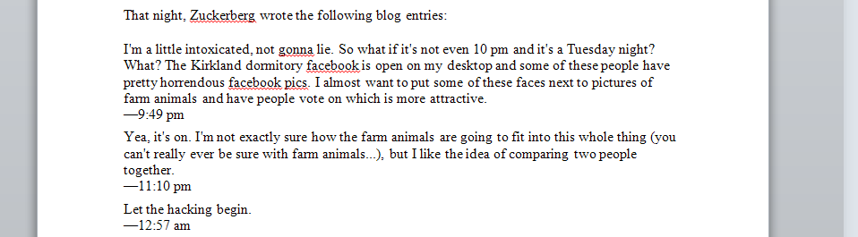
- (After the 1st paragraph)
Select the section- “That night, Zuckerberg wrote the following. . .” through “the three (3) blog entries”.
  - Apply the “Intense Emphasis” Style.
  - Apply a .5” ( ½ ) Left Indentation. Hint: Ctrl + m

- First-line indent EACH paragraph other than the Zuckerberg blog entries. (There are 15 paragraphs)
- Select the side heading thefacebook.com and apply the “Heading 1” Style.
- Justify the 1st paragraph under the side heading thefacebook.com. (In January 2004, . .)

- Press ctrl+ home to go to the beginning of the document.
  - Find both occurrences of the word “entrepreneur”.
  - Replace them with a synonym.

- Set the Line Spacing of the “Last Paragraph” of this report to Exactly 20pt. (Last Paragraph Only). Hint: Open Paragraph Dialog Box.
- Open the file “Active Users and copy and paste it at the end of the document.
- Convert Text to Table.
  - Separated by Tabs
  - AutoFit to Contents
  - Apply “Grid Table 4 – Accent 1”
  - Alignment: Center-Heading Row | Right-Dates | Center-Numbers
  - Center Table Horizontally
(Table Tools-Layout > Table > Properties)

- Center Align the 2nd paragraph. (Starts with “According to The Harvard Crimson. . .”)

- On Page 2- Select the 4th paragraph (“Just six days after. . .”)
- Set the Left and Right indentation to .5”
- Set Alignment to Justify for this paragraph.

- On page 3- Apply a “Bulleted List” to the four names (“Eduardo Saverin, Dustin Moskovitz….”)
  - Extra Credit: Define Bullets with “FacebookLogo” picture from Teacher website.
Go to Beginning of Document (ctrl+home)
- Select the “1st Paragraph” of the document.
  - Create a “Box” Paragraph Border, Black Text 1, 1 ½ pt width.
  - Shading “White, Background 1, Darker 50%”
- On page 2 – Hyperlink the side heading “thefacebook.com” to the webpage “http://www.facebook.com”. Select the text, go to Insert, click hyperlink, in Address type the web address.

- On page 4 – Apply the “Heading 1” Style to “Facebook – Total Active Users”

- Insert the Picture of Mark Zuckerburg from the Teacher Website at the end of the document.
- Wrap Text – “In front of Text”
- “Position in bottom left with square text wrapping”.
- Apply 4 ½ pt Border around the picture.

- Insert an Austin Quote text box at the end of the document with the text: “Mark Zuckerburg in his dorm”.
  - Text wrap the text box behind text. Drag it to the right of the picture.
- Select the very last paragraph, (On March 12, 2012, Yahoo!. . .) and keep lines together
- Prevent this Paragraph from Breaking between page 3 and 4. (Hint: Home > Paragraph)

- Select the 1st appearance of “Yahoo!” in the very last paragraph.
  - Apply the Text Effect “Fill-Turquoise, Accent 2, Outline- Accent 2”
  - Set the font size to 16.

- Save the document again.

- Turn in your assignment.

You are Finished!!!

